* **Idea Summary:**

Paramount has requested a feature in ARM to verify if an asset’s owner is active in AD or HR before sending email notifications during assignment.

* **Problem Definition:**

Currently, the ARM module does not validate if an asset owner is active in AD or HR. This can lead to emails being sent to inactive or disabled accounts. The client would like to introduce this validation to improve accuracy and communication efficiency.

Additionally, including a new column to display whether the owner’s account is disabled in AD is proposed as a useful enhancement.

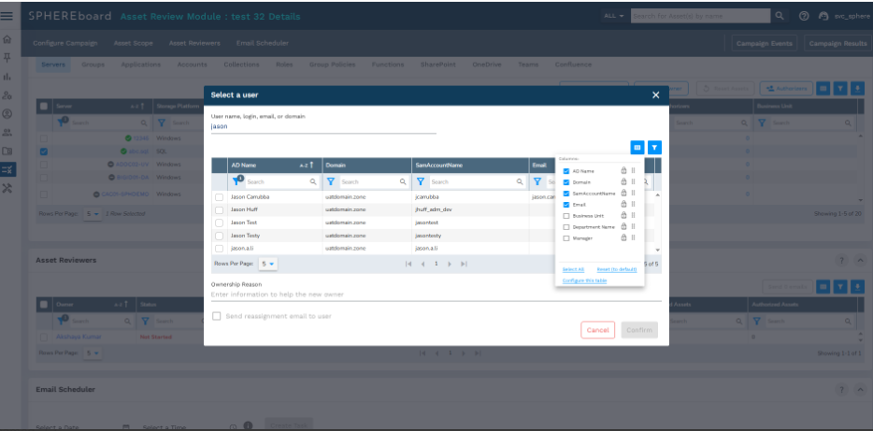

**As a** *user*

**When** – *assigning owners to assets and initiating email notifications,*

**I want to** – to check the owner’s status—whether they are active or their account is disabled.

**So I can** – E*nsure emails are only sent to active users and assets are assigned appropriately.*

personWho is Facing This Problem:

*Paramount*

admission ticketsZenDesk Ticket Link: